Srs-File Flatfindr

Introduction

Fatfindr is a webpage where you can rent rooms or studios. This product is modified by the ese2016-team1 for the university bern. The flatfindr-webpage is not a new project, the ese2016-team1 group was just ask to add new features. This Srs-file however is created from scratch.

This documentation of the created for the developers of the webpage, as well as any other member of the ese2016-team1 group, which are connected to this project. It also intends to inform the customer as well as every tester and potential user of the webpage.

Flatfindr is a webpage, where people can either give their give their properties for rent or rent a propertiy of another user. You can search for your desired place an get in touch with its current owner for further questions or to arrange a visit.

Overall description

This product is a modification of the flatfindr-webpage. The already existing one has not been created by the ese2016-team1.

This project includes features like:

Register and Login/Logout
A new User has to register first. This requires him to state his first and last name, his prefered e-mail adress as well as a password for his new account.
To login to an already created account the User must state his e-mail and his password again.
Once logged in a User can log out any time he wants.
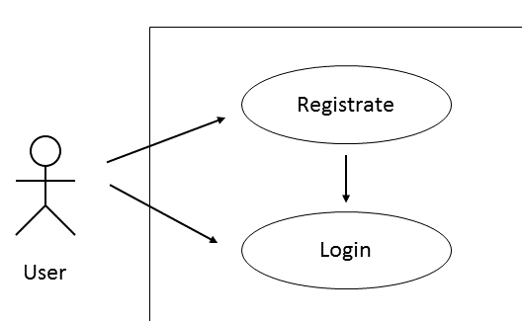

Advertising
A User can create a new advertisment for a property he wants to rent to someone. He states some information about it (e.g. Location, type), and places the ad.
A User is also able to search for existing ads and to check out their information. If he/she likes a certain ad there is an option to bookmark it.

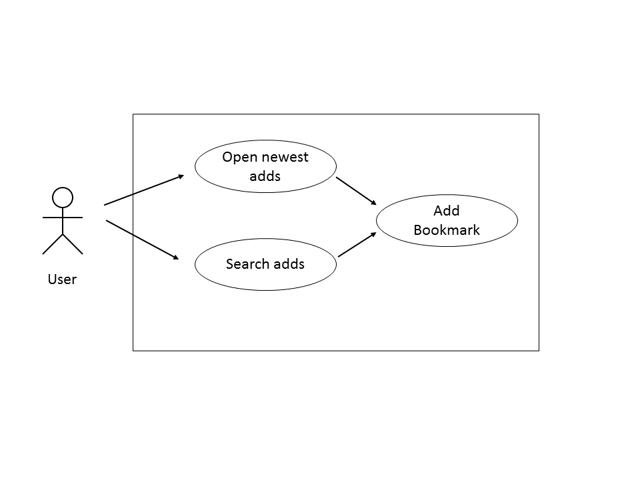
Message
A User has the ability to send and receive messages directly on the flatfindr-webpage to other user of the site. Receiving messages are stored in order, so you can read them chronologically. You have also the ability to respond directly with an answer-mail.
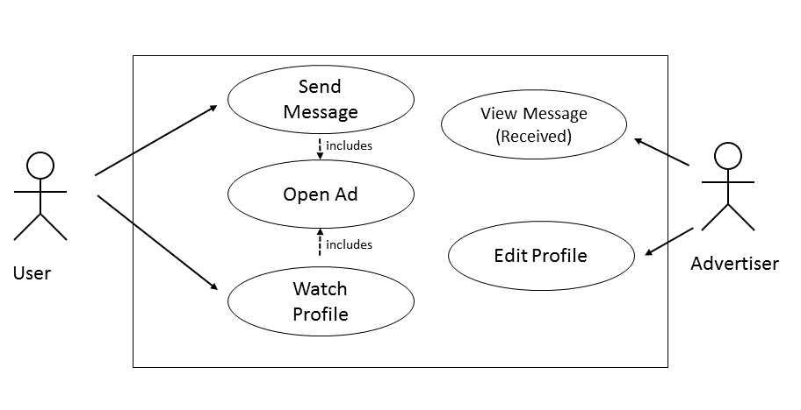
Enquiries
If there is an ad you really like and want to see a place in real life you can send an enquiry to its owner directly through the ad. The owner then can accept or reject your enquiry.
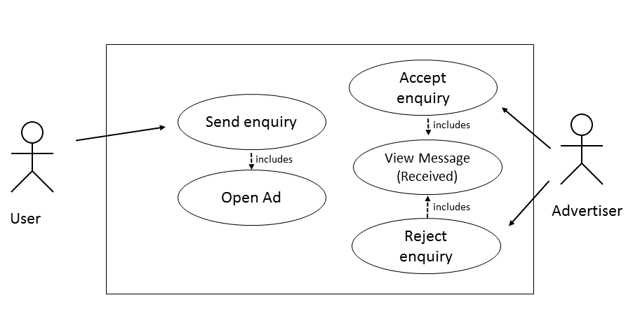
Ad alerts
A User can create an ad alert, which will tell him when someone put up an ad that fulfills the criterias given in the alert.

Manage scheduled visits

Buy and Sell
A User has not just the ability to rent properties he can buy and sell them too. The buy/sell functions the same way. Users create ads which are visited by other users. Messages are sent between the two parties and visits are scheduled.

Auction
For selling a place you have another possibility. You can create an auction on which intersted people can bet.

Premium User
A normal User has the ability to buy premium-membership. As a premium user his ads are placed higher as those of normal users. His alert also notifies him faster than the ones of normal user.

GUI
There are no key-shortcuts implemented in the project. A User operates the site with the curser.
The site looks like this.
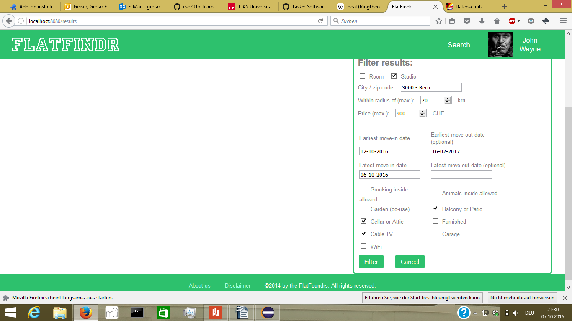
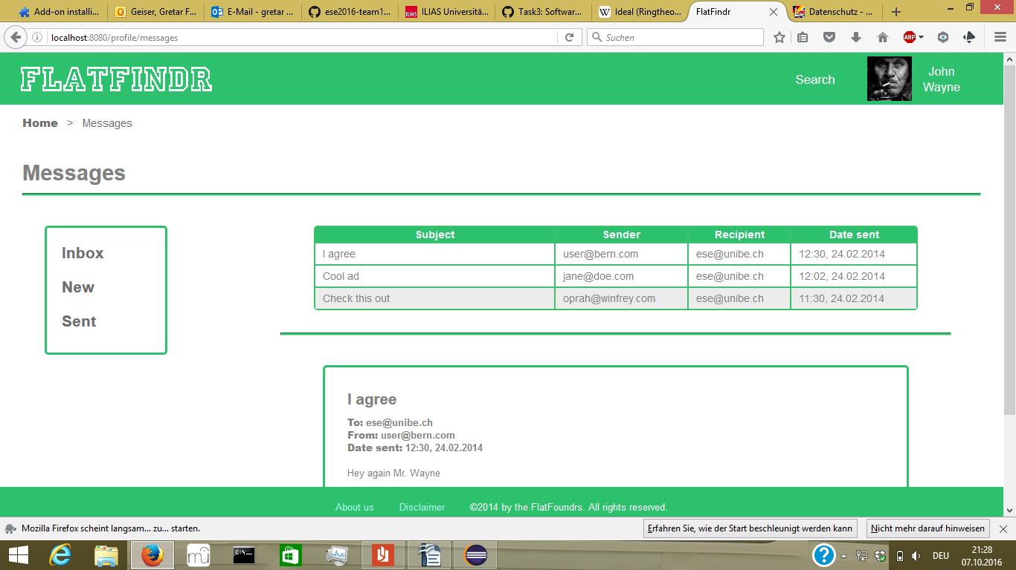

Specific Requirements

The website should be open to visit on any webbrowser.

The following dates will be secured if someone enters the flatfindr-webpage:
Ip-adress, date, time, browser request, information about the browser as well as the system software
This is for security reasons.
Users are protected under the copy right and the privacy protection law.

